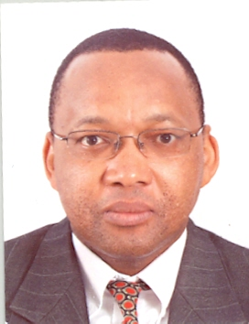
Profile: MZWANELE GRIFFITHS MFUNWA
Mzwanele G. Mfunwa is the Economic Affairs Officer in the Southern Africa Office, Lusaka-Zambia, of the UN Economic Commission for Africa (UNECA), which he joined in 2004. Over the course of 15 years he has served UNECA in its offices in Ethiopia, Niger and now in Zambia, focusing on macroeconomics, private sector promotion, trade, and economic governance. During his tenure at UNECA he has been a Visiting Scholar at the German Development Institute in Bonn, Germany, where he published the paper Strengthening Internal Accountability in the Context of Programme-based Approaches in Sub-Saharan Africa in 2006, among other publications. Prior to joining the UNECA, Dr. Mfunwa, a South African national, has worked as an economist in several national and international organizations, including the International Monetary Fund in Washington DC, South African Reserve Bank and the National Treasury of South Africa. Dr. Mfunwa obtained his Doctor of Commerce Degree (Economics) at the University of Pretoria in 1998; MSc. (Economics) at the University of Illinois-Urbana/Champaign in 1992; and Bachelor of Commerce and Bachelor of Commerce Honours (Economics) degrees at Rhodes University in 1988 and 1989, respectively.

